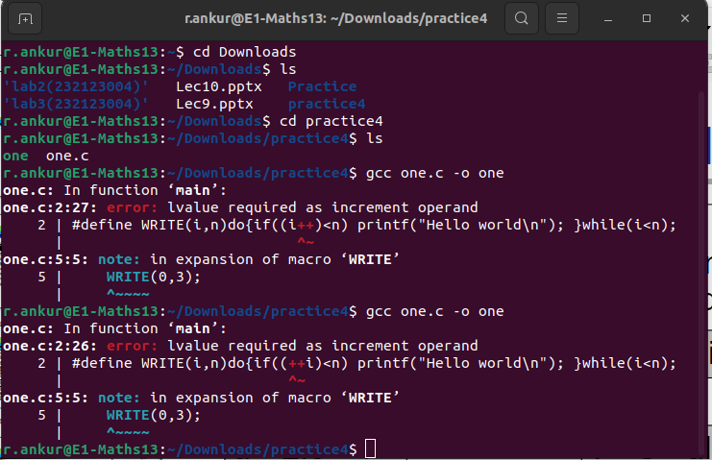
Error is showing because here i is const, and we are trying to increment i, thats why its an l value error.

